Describe current and emerging technological trends

Current and Emerging Technological Trends
Technology impacts many aspects of our lives with no sign of slowing. Here are some current and emerging technology trends:

Robots  A robot is a mechanical but virtual intelligent machine that can repeatedly perform tasks automatically or by remote control.  Robots work in factories that assemble vehicles, and can also have roles in the film industry and fight wars in ways such as unmanned planes. In 1984 a film called The Terminator was released. It featured a future world where the military created robots to fight wars. | 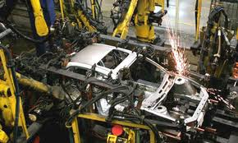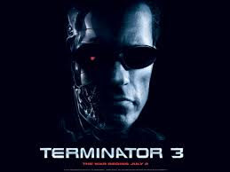
Computer-Aided Learning (CAL):  CAL focuses on teaching at a distance in an anywhere anytime environment.  CAL is also used to provide simulations of training for real or dangerous situations for  Examples of CAL include virtual classrooms and Flight Simulator for the space program or to fly an airline | 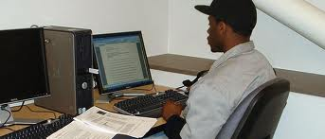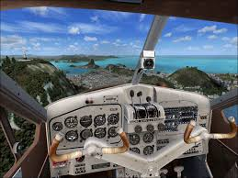
Games:  These programs often simulate real or imaginary situations.  Examples include military games such as Call of Duty and Modern Warfare; simulations for flying a plane or playing basketball; or general games to find goals and gather points for saving a city. | 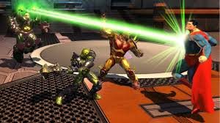
Video conferencing
Video conferencing allows computer users in different locations or even countries to see, hear, and interact among each other, and even share computer screens as if they were in the same room.
If your computer has hardware such as microphones, speakers and a video camera, then you can take part in video conferencing.
It is best to have a good Internet connection so that you can send and receive images and large files quickly and easily.

Control software:  Used to program external devices that have repetitive tasks, such as traffic lights where programmed instructions are used to control traffic on highways.  They can also be used in other situations such in the space program, satellites, bomb disposal.  CAD, CAE and CAM all use control software. | 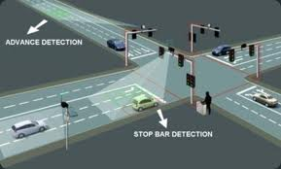
Computer-Aided Design (CAD)  This is the use of special computer software to design products including jewelry, vehicles, ships, parts, architectural designs and prosthetics. | 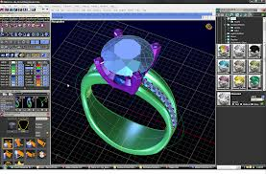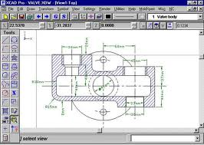
Computer-Aided Engineering (CAE)  This is an area of CAD that focuses on engineering areas, specifically to analyze the robustness and reliability of parts and objects such as buildings and vehicles.  CAE can also be used to improve the safety and durability of vehicles | 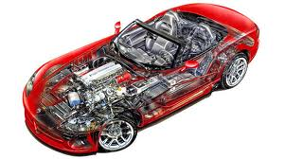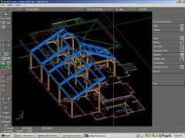
Computer-Aided Manufacture (CAM)  This is another area of CAD that is used to develop and test products and related machinery in the manufacturing of work pieces.  The model is designed in CAD and tested using CAE, CAM software is then used to control the machine tool to produce the final mold or product. | 